7COM1079-0901-2025 - Team Research and Development Project

Final report title: The Relationship between Hosting the Summer Olympic Games and Total Medal Success

Group ID: A162

Dataset number: DS009

Prepared by: Kasireddy Sriharsha Reddy- 24133646
Manoj Reddy Gurram - 24162283
Sanjana Gandla - 24133128
Sai Varsha Vemulaplli - 24158581
Vinuthna Mallela

University of Hertfordshire
Hatfield, 2025

Table of Contents
1. Introduction 3
1.1 Problem Statement and Research Motivation 3
1.2 The Data Set 3
1.3 Research Question 3
1.4 Null and Alternative Hypotheses 3
2. Background Research 5
2.1 Research Papers 5
2.2 Why the Research Question Is of Interest 5
3. Visualisation 6
3.1 Appropriate Graphs for the Research Question 6
3.2 Additional Information Relating to Understanding the Data 7
3.3 Useful Information for Data Understanding 7
4. Analysis 8
4.1 Statistical Test Used and Output 8
4.2 Hypothesis Decision Based on p-value 8
5. Evaluation – Group Experience 9
5.1 What Went Well 9
5.2 Points for Improvement 9
5.3 Group’s Time Management 9
5.4 Project’s Overall Judgement 9
6. Conclusions 9
7. Reference List 11
8. Appendices 12
Appendix A – R Code 12

1. Introduction

1.1 Problem Statement and Research Motivation
Olympic medal performance is one of the major pointers to the sporting success and international competitiveness of a country. Olympic Games can affect the results of medals because they can offer certain benefits to the host country, including the development of sports facilities and infrastructure, more training of athletes, and the possibility to be acquainted with the conditions of competition (Zhang et al., 2025). Past studies indicate that there exists a host-nation advantage where host countries tend to have higher performance results. The knowledge of this relationship is critical in assessing the contribution of structural and contextual factors toward the long-term Olympic success.

1.2 The Data Set
The source of the data is the data. World platform and it is the historical data of the nation's performance and participation in the Summer Olympic Games. It consists of total Summer Olympic medals, the number of Games attended by a country, the number of times the country has hosted Summer Olympics, and the identification of countries. This data is appropriate to analyse because it has homogeneous numerical indices that are needed to explore correlations between hosting frequency and medal performance.

1.3 Research Question
- Is the relationship between the number of times a country has hosted the Summer Olympic Games and the total number of Summer Olympic medals statistically significant?

1.4 Null and Alternative Hypotheses
H₀ (Null Hypothesis): The number of times a country has hosted the Summer Olympic Games does not have any statistically significant correlation with the total number of Summer Olympic medals that a country has won.
H₁ (Alternative Hypothesis): The count of Summer Olympic games hosted by a country has been statistically significant with the total number of Summer Olympic medals.
The action of rejecting the null hypothesis means that hosting frequency has a statistically significant relationship with success in national Olympic medals. A failure to reject the null hypothesis will imply that hosting the Olympics is not significantly related to long-term medal performance.

2. Background Research

2.1 Research Papers
Factors that influence the performance of the Olympics have been widely studied before. One of the studies explores the advantage of the host nation, in which they seek to establish whether nations benefit more by hosting the Olympic Games. The results indicate that the host nations tend to record better results in medals because of the escalated investments, familiarity with the host city, and the home support (Sassenberg et al., 2025). A different study considers more general factors of Olympic success and examines the economic potential, population, and long-term participation. The findings point to the fact that long-term investment and involvement are the factors that help to add medals. The third paper examines the issue of inequality in the allocation of medals and shows that Olympic medals have always been taken by a few countries (which are often ranked in the top tables), and many countries have only a few successes (Bernini and Dubreucq-Perus, 2026). These works apply to the current study because they all indicate that structural benefits, such as hosting opportunities, are important in determining long-term Olympic medal results.

2.2 Why the Research Question Is of Interest
The literature tends to concentrate on short-term host-nation impacts of single Olympic Games, and very little has been done concerning the long-term consequences of repeated hosting. This research fills this gap with a data set that represents the cumulative frequency of hosting and overall medal success in more than one Olympic cycle. Results can be used to inform other studies in the future by motivating them to examine hosting history alongside economic and demographic performance determinants in greater depth.

3. Visualisation

3.1 Appropriate Graphs for the Research Question
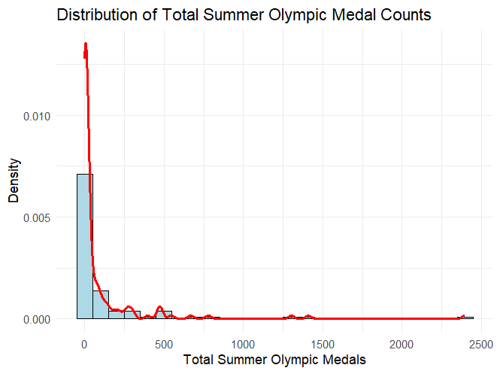
Figure 1: Distribution of Total Summer Olympic Medal Counts with Density Curve
(Source: R Studio)
The distribution of total Summer Olympic medal counts in the histogram is highly skewed to the right, with most of the countries recording rather low counts, with a few countries recording a very high count. This imbalance is brought out by the density curve, which implies that there is a significant imbalance in the distribution of medals among participating nations.

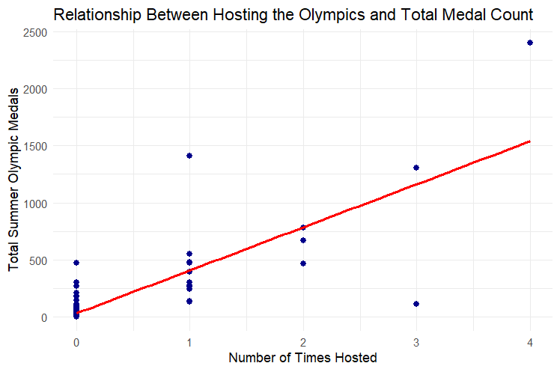
Figure 2: Relationship between Hosting the Olympics and Total Summer Olympic Medal Count
(Source: R Studio)
The scatter plot shows that there is a positive linear correlation between the number of times a country has hosted Summer Olympic Games and its total number of medals. The directional trend of the regression line shows that the higher the number of hosting events, the greater the number of cumulative medals achieved by the country, which proves the existence of a strong relationship.

3.2 Additional Information Relating to Understanding the Data
The histogram is used to reveal the overall distribution, spread, and skewness of total Summer Olympic medal counts across countries. The scatter plot illustrates how medal totals vary with hosting frequency, enabling visual assessment of the strength, direction, and linearity of the relationship between hosting the Olympics and national medal performance.

3.3 Useful Information for Data Understanding
According to the visualisations, the distribution of the Olympic medals is strongly skewed right, with the majority of the countries having comparably low numbers. There is an evident positive linear trend in the relationship between the hosting frequency and medal success (Wang et al., 2025). Long-term dominance in the performance of the Olympics is evidenced by notable outliers like the United States, which show remarkably high medal counts.

4. Analysis

4.1 Statistical Test Used and Output
Table 1: Pearson Correlation Test Results

Statistic | Value
Correlation coefficient (r) | 0.812
p-value | < 0.001
Test type | Pearson correlation
Variables analysed | Number of times hosted, Total Summer Olympic medals
Sample size (n) | 138
The correlation test is a Pearson test that is applicable to test the linear relationship existing between the number of times that a country has hosted the Summer Olympic Games and the total number of medals. The test fits well since the two variables are continuous, and the research objective is to test the level of association. The findings show the positive correlation between hosting frequency and medal success is strong (r = 0.812) and statistically significant (p < 0.001), which implies the significance of the relationship between the hosting frequency and the success of the medals.

4.2 Hypothesis Decision Based on p-value
The null hypothesis is rejected because the p-value is less than 0.05, which is the level of significance. The high positive correlation implies that the higher the frequency of the Olympics, the higher the total number of medals is likely to be attained in the countries that are more likely to host the Olympic Games. This statistically significant value indicates that there is no high chance that the identified relationship could have resulted arbitrarily.

5. Evaluation – Group Experience

5.1 What Went Well
The team collaborated well during the project, and there was effective communication and equal participation of all members. The division of tasks was according to individual strengths, and the division of tasks enhanced efficiency. Data analysis and visualisation using R were effective, and each member helped in coding, interpretation and preparation of reports.

5.2 Points for Improvement
Pre-planning would have enhanced the efficiency of the workflow, especially at the early stages of the plan (Kerzner, 2025). Additional time might have been spent investigating academic literature to enhance the theoretical background. In addition, more frequent version control features, usage in GitHub, would have minimised overlapping edits and enhanced coordination.

5.3 Group’s Time Management
The team was also very effective in its time management as it organised frequent meetings to go through the progress and discuss issues. Distribution of tasks was done in a clear way and members were allowed to work individually but within the common deadlines (Kerzner, 2025). The majority of the milestones were met within the expected time, yet the literature-related tasks would have been scheduled earlier, and the time management would be even better.

5.4 Project’s Overall Judgement
The project, in general, proved to be successful and was able to achieve its intended goals. The group was able to use the methods of statistical analysis, derive adequate visualisations and respond to the research question coherently. The project improved the knowledge of data analysis with the help of R and increased the teamwork, analytical and scholarly writing skills.

5.5 Comment on the GitHub log output
“The GitHub log shows consistent contributions from all group members across the project. The commits reflect steady progress in research, coding, analysis, and report writing. The selected significant commits highlight key stages of development, including data preparation, formation of the research question, and completion of the statistical analysis. Overall, the log demonstrates effective collaboration.”

6. Conclusions
The correlation analysis in this paper was conducted to determine the correlation between the frequency of hosting the Olympics and the overall number of Summer Olympic medals. The findings indicated a positive correlation that was high and statistically significant, with graphic trends and a high correlation coefficient. These results suggested that nations that hosted the Olympics with greater frequency were more likely to realise long-term success in terms of the number of medals won, which was probably because of structural benefits, in terms of higher investment and development of infrastructure. Nonetheless, the research could not be generalised due to the aggregated data and omission of other variables like population size and economic capacity. Further studies may use a multivariate regression to bring more meaning.

7. Reference List
Kerzner, H., 2025. Project management: a systems approach to planning, scheduling, and controlling. John Wiley & Sons.
Sassenberg, C., Prentice, C. and Thaichon, P., 2025. The effect of infrastructure on the social legacy of mega sporting events. Multidisciplinary Business Review.
Bernini, A. and Dubreucq-Perus, C., 2026. Winning at Home? Gender Inequality, Corruption, and the Host Country’s Olympic Success. Journal of Sports Economics, p.15270025251386403.
Zhang, Z., Ma, T., Yao, Y., Xu, N., Gao, Y. and Xia, W., 2025. Predicting Olympic Medal Performance for 2028: Machine Learning Models and the Impact of Host and Coaching Effects. Applied Sciences, 15(14), p.7793.
Wang, Y., Fei, Y. and Zhang, Q., 2025. A Symmetry-Aware Predictive Framework for Olympic Cold-Start Problems and Rare Events Based on Multi-Granularity Transfer Learning and Extreme Value Analysis. Symmetry, 17(11), p.1791.

8. Appendices

Appendix A – R Code
# 1. Clear workspace
rm(list = ls())

# 2. Load required libraries
library(ggplot2)
library(dplyr)

# 3. Load dataset
data <- read.csv(
"Summer Olympics medal count, participation, hosting - Sheet2.csv",
stringsAsFactors = FALSE
)

# 4. Inspect data structure
str(data)
head(data)

# ------------------------------------------------
# 5. Histogram (Required Supplementary Graphic)
# ------------------------------------------------
ggplot(data, aes(x = total_summer)) +
geom_histogram(
aes(y = ..density..),
bins = 25,
fill = "lightblue",
color = "black"
) +
geom_density(color = "red", linewidth = 1) +
labs(
title = "Distribution of Total Summer Olympic Medal Counts",
x = "Total Summer Olympic Medals",
y = "Density"
) +
theme_minimal()

# ------------------------------------------------
# 6. Scatter Plot (Main Visualisation)
# ------------------------------------------------
ggplot(data, aes(x = no_hosted, y = total_summer)) +
geom_point(color = "darkblue", size = 2) +
geom_smooth(method = "lm", se = FALSE, color = "red") +
labs(
title = "Relationship Between Hosting the Olympics and Total Medal Count",
x = "Number of Times Hosted",
y = "Total Summer Olympic Medals"
) +
theme_minimal()
# ------------------------------------------------
# 7. Correlation Test (Pearson)
# ------------------------------------------------
correlation_test <- cor.test(
data$no_hosted,
data$total_summer,
method = "pearson"
)

print(correlation_test)
# ------------------------------------------------
# 8. Decision Based on p-value
# ------------------------------------------------
alpha <- 0.05

if (correlation_test$p.value < alpha) {
decision <- "Reject the null hypothesis"
} else {
decision <- "Fail to reject the null hypothesis"
}

print(decision)

